EUROPEAN INNOVATION COUNCIL AND SMES
EXECUTIVE AGENCY (EISMEA)

Innovation Ecosystems, SMP/Entrepreneurship and Consumers
SMP/Internal Market and Consumers

GRANT APPLICATION FORM
FOR ‘GRANTS FOR AN ACTION’
Part A
(Mono- & Multi-beneficiaries)

PROGRAMME CONCERNED
Support to joint enforcement actions
REFERENCE NUMBER OF THE CALL FOR PROPOSALS
SMP-IMA-2021-3-JA-2731-12302
SUMMARY OF THE APPLICATION
Title:
Identity of the Coordinator:
Summary of the action in English:

Duration (in months):
Requested amount (in €):

Before filling in this form, please carefully read the relevant call for proposals, the guide for applicants and any other reference documents related to this grants programme available on our site.
Please make sure that your application:
- is submitted on the correct form, completed in full and dated;
- is signed by the person authorised to enter into legally binding commitments on behalf of the applicant;
- presents a budget in conformity with the funding rules;
- meets the submission arrangements set out in the call;
- is submitted by the deadline.
The evaluation committee or, where appropriate, the authorising officer responsible may ask an applicant to provide additional information or to clarify the supporting documents submitted in connection with the application, provided that such information or clarification does not substantially change the proposal.
By submitting an application the applicant accepts that in case of award certain data like the name, locality and amount (amongst others) will be published.

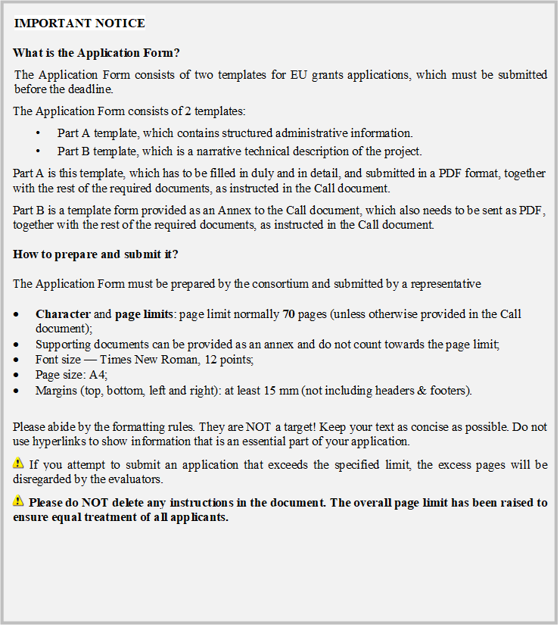

I. INFORMATION ON THE APPLICANTS (one form for each project)

1 REFERENCES OF THE APPLICANTS

1.1 Coordinator
1.1.1 IDENTITY OF THE APPLICANT
Official name in full:
Acronym:
(if applicable)
Official legal form:
(Not applicable if the applicant is a natural person)
Legal personality:
(Reply by "YES" or "NO").

(In case you answered "NO"):
For entities with no legal personality under national law please indicate the representative empowered to take part in court proceedings on their behalf:
Place of establishment or registration:
(Address and country)
Entity registration number:
(Not applicable if the applicant is a public-sector body. For natural persons, the applicant should indicate the number of his/her identity card or, failing that, of his passport or equivalent.)
VAT number (if applicable):
PIC number:
Legal entity details will be asked to the eligible applicants in a subsequent procedural phase by REA (Research Executive Agency).

1.1.2 CONTACT DETAILS
Street address:
Postcode:
City:
Region (if applicable):
Country:
Telephone: Mobile:
Fax:
E-mail address:
Website:
Any change in the addresses, phone numbers, fax numbers or e-mail, must be notified in writing to the Authorising Officer. The Authorising officer will not be held responsible if it cannot contact an applicant.
1.1.3 CONTACT PERSON RESPONSIBLE FOR THE PROPOSAL/Coordinator
Family name: First Name:
Position/Function:
Telephone: Mobile:
Fax:
E-mail address:

1.1.4 LEGAL REPRESENTATIVE (PERSON AUTHORISED TO SIGN THE AGREEMENT)
Family name: First Name:
Position/Function/Mandate:
Telephone: Mobile:
Fax:
E-mail address:

1.1.5 ORGANISATION DETAILS
Is your Organisation independent? | Y | N | Number of employees
If No, please indicate name(s) of owner(s) who own 25 % or more or the public authority supervising your organisation
Business Area
Internet homepage

1.1.6. INFORMATION CONCERNING PARTICIPATION AND INVOLVEMENT
Amount of funding which the company/ organisation undertakes to provide for the operation (in Euro)
By which means and when will the co-financing take place?
Is the co-financing decision irrevocable?
(if the answer is “No”, please comment)
Role and involvement in implementing the proposed project

1.2 Applicant No 2 (Repeat this part as often as is required to include all applicants).
1.2.1 IDENTITY OF THE APPLICANT
Official name in full:
Acronym:
(if applicable)
Official legal form:
(Not applicable if the applicant is a natural person)
Legal personality:
(Reply by "YES" or "NO")

(In case you answered "NO"):
For entities with no legal personality under national law please indicate the representative empowered to take part in court proceedings on their behalf:
Place of establishment or registration:
(Address and country)

Entity registration number:
(Not applicable if the applicant is a public-sector body. For natural persons, the applicant should indicate the number of his/her identity card or, failing that, of his passport or equivalent)
VAT number (if applicable):
PIC number:
Legal entity details will be asked to the eligible applicants in a subsequent procedural phase by REA (Research Executive Agency).

1.2.2 CONTACT DETAILS
Street address:
Postcode:
City:
Region (if applicable):
Country:
Telephone: Mobile:
Fax:
E-mail address:
Website:
Any change in the addresses, phone numbers, fax numbers or e-mail, must be notified in writing to the Authorising Officer. The Authorising Officer will not be held responsible if it cannot contact an applicant.

1.2.3 CONTACT PERSON RESPONSIBLE FOR THE PROPOSAL
Family name: First Name:
Position/Function:
Telephone: Mobile:
Fax:
E-mail address:

1.2.4 LEGAL REPRESENTATIVE (PERSON AUTHORISED TO SIGN THE AGREEMENT)
Family name: First Name:
Position/Function/Mandate:
Telephone: Mobile:
Fax:
E-mail address:

1.2.5 ORGANISATION DETAILS
Is your Organisation independent? | Y | N | Number of employees
If No, please indicate name(s) of owner(s) who own 25 % or more or the public authority supervising your organisation
Business Area
Internet homepage

1.2.6. INFORMATION CONCERNING PARTICIPATION AND INVOLVEMENT
Amount of funding which the company/ organisation undertakes to provide for the operation (in Euro)
By which means and when will the co-financing take place?
Is the co-financing decision irrevocable?
(if the answer is “No”, please comment)
Role and involvement in implementing the proposed project

1.3 Affiliated Entity No 1 (Repeat this part as often as is required to include all affiliated entities).
1.3.1 IDENTITY OF THE AFFILIATED ENTITY
(This box shall be filled in by all affiliated entities, including the case where several entities satisfy the criteria for being awarded a grant and together form ONE entity, to be treated as the sole beneficiary.)
Official name in full:
Acronym:
(if applicable)
Official legal form:
(Not applicable if the applicant is a natural person)
Legal personality:
(Reply by "YES" or "NO"):

(In case you answered "NO"):
For entities with no legal personality under national law please indicate the representative empowered to take part in court proceedings on their behalf:
Place of establishment or registration:
(Address and country)

Entity registration number:
(Not applicable if the applicant is a public-sector body. For natural persons, the applicant should indicate the number of his/her identity card or, failing that, of his passport or equivalent.)
VAT number (if applicable):
PIC number:
Legal or capital link with the applicant, if applicable:
The applicant should provide a short description of the legal or capital link with the applicant and provide the statutory documents and/or consolidated accounts.

1.3.2 ORGANISATION DETAILS
Is your Organisation independent? | Y | N | Number of employees
If No, please indicate name(s) of owner(s) who own 25 % or more or the public authority supervising your organisation
Business Area
Internet homepage

1.3.3. INFORMATION CONCERNING PARTICIPATION AND INVOLVEMENT
Amount of funding which the company/ organisation undertakes to provide for the operation (in Euro)
By which means and when will the co-financing take place?
Is the co-financing decision irrevocable?
(if the answer is “No”, please comment)
Role and involvement in implementing the proposed project

2 BANK DETAILS
Bank details will be asked to the eligible applicants in a subsequent procedural phase by REA (Research Executive Agency).

3 PROFILE OF THE APPLICANTS

3.1 Applicant No1 Coordinator
PROFILE OF THE Coordinator — GENERAL AIMS AND ACTIVITIES
[Year of foundation]:
The entity shall state his legal status by ticking one or several options:
Public body International Organisation
Non-profit making organisation Social Partner
Educational and training establishment Research Centre/Institute
Other (please specify) SME
Natural Persons
Private Entity

The Coordinator should provide a short description of the organisation/group/consortium including affiliated entities. Where appropriate include information on membership, with respect to the eligibility criteria indicated in the specific call.

3.2 Applicant No 2 (Repeat this part as often as is required to include all applicants)
PROFILE OF THE APPLICANT — GENERAL AIMS AND ACTIVITIES
[Year of foundation]:
The entity shall state his legal status by ticking one or several options:

Public body International Organisation
Non-profit making organisation Social Partner
Educational and training establishment Research Centre/Institute
Others (please specify) SME
Natural Persons
Private Entity

3.3 Affiliated Entity No 1 (Repeat this part as often as is required to include all affiliated entities)
PROFILE OF THE AFFILIATED ENTITY No 1 — GENERAL AIMS AND ACTIVITIES
[Year of foundation]:
The entity shall state his legal status by ticking one or several options:
Public body International Organisation
Non-profit making organisation Social Partner
Educational and training establishment Research Centre/Institute
Others (please specify) SME
Natural Persons
Private Entity

Only for public bodies-legal status GOV (to be taken out if not applicable): I declare that the financial workflows of the public officials employed in this action are fully under my control and a part of their salary is booked to eligible costs only to carry out activities in addition to our routine activities. | Yes | No

II. OPERATIONAL CAPACITY (one form for each project)

1 OPERATIONAL CAPACITY

1.1 Coordinator
OPERATIONAL CAPACITY TO COMPLETE THE PROPOSED ACTION OF THE APPLICANT
Applicants have to submit a declaration on their honour, and the following supporting documents:
- curriculum vitae or description of the profile of the people primarily responsible for managing and implementing the operation;
- an exhaustive lists of previous projects and activities performed by the people primarily responsible for managing and implementing the operation (the table to be filled in can be found at the end of Application form, Part B).

1.2 Applicant No2 (Repeat this part as often as is required to include all applicants)
OPERATIONAL CAPACITY TO COMPLETE THE PROPOSED ACTION OF THE APPLICANT
Applicants have to submit a declaration on their honour, and the following supporting documents:
- curriculum vitae or description of the profile of the people primarily responsible for managing and implementing the operation;
- an exhaustive lists of previous projects and activities performed by the people primarily responsible for managing and implementing the operation (the table to be filled in can be found at the end of Application form, Part B).

1.3 Affiliated Entity No1 (Repeat this part as often as is required to include all affiliated entities)
OPERATIONAL CAPACITY TO COMPLETE THE PROPOSED ACTION OF THE AFFILIATED ENTITY No 1
Applicants have to submit a declaration on their honour, and the following supporting documents:
- curriculum vitae or description of the profile of the people primarily responsible for managing and implementing the operation;
- an exhaustive lists of previous projects and activities performed by the people primarily responsible for managing and implementing the operation (the table to be filled in can be found at the end of Application form, Part B).
III. ADDITIONAL FUNDING (one form for each project)

1 UNION FUNDING

1.1 APPLICATIONS AND/OR ONGOING FUNDING OF THE UNION
Have any of the applicants or affiliated entities received or applied for any Union funding for the same action or part of the action or for its functioning during the same financial year?
NO
YES — Continue to the following table

APPLICATION, GRANT OR ANY OTHER EU FUNDING — To be specified for each of the applications or obtained grants in the current or previous years (add columns if necessary)
 | Programme 1 | Programme 2
Title of the action (or part of the action)
Union Programme concerned
Union Institution or Body/Agency to which the application was submitted or which took the award decision
Year of award or application and duration of the operation
Value of the application, grant or other Union funding

LEGAL NOTICE
Applicants must inform the Agency to which this application is submitted if any of the above-mentioned applications for funding made to other European Commission departments or Union Institutions or bodies/agencies has been approved by them after the submission of this grant application.

2 OTHER SOURCES OF EXTERNAL FUNDING — NON UNION
2.1 SUPPORT AWARDED
Have any of the applicants or any of the affiliated entities already received confirmation relating to any external funding for the action?
NO
YES — Continue to the [table in the Annexes (Budget)] [following table]

The reply to any call for proposals involves the recording and processing of personal data (such as name, address and CV). Such data will be processed pursuant to Regulation (EU) No 2018/1725 on the protection of individuals with regard to the processing of personal data by the Union institutions, bodies and agencies and on the free movement of such data. Unless indicated otherwise, the questions and any personal data requested that are required to evaluate the application in accordance with the call for proposal will be processed solely for that purpose by Head of Unit, EISMEA Unit I.03/SMP/Internal Market and Consumers. The responsibility of the data controller of the granting authority EISMEA Unit I.03/SMP/Internal Market and Consumers, Head of Unit (email: EISMEA-MSJA-NON-FOOD-PRODUCTS-2021@ec.europa.eu).
Personal data may be registered in the Early Detection and Exclusion System by the Commission, should the beneficiary be in one of the situations mentioned in Articles 136 and 141 of Regulation (EU, Euratom) 2018/1046. For more information see the Data Protection Notice on: https://eismea.ec.europa.eu/system/files/2021-04/EISMEA-DPN-calls.pdf.

Legal personality is understood as applicant’s capacity to sign contracts and constitute a party in court proceedings under the applicable national legislation.
Legal personality is understood as applicant’s capacity to sign contracts and constitute a party in court proceedings under the applicable national legislation.
Legal personality is understood as applicant’s capacity to sign contracts and constitute a party in court proceedings under the applicable national legislation.
Regulation (EU) 2018/1725 of the European Parliament and of the Council of 23 October 2018 on the protection of natural persons with regard to the processing of personal data by the Union institutions, bodies, offices and agencies and on the free movement of such data, and repealing Regulation (EC) No 45/2001 and Decision No 1247/2002/EC (OJ L 295, 21.11.2018, p. 39).
https://eur-lex.europa.eu/legal-content/EN/TXT/?uri=CELEX%3A32018R1046

