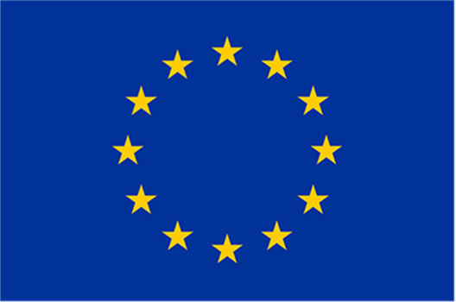

Single Market Programme
(SMP COSME)

Call for proposals
EU SME Centre in China – phase IV
(SMP-COSME-2021-SMECC)

Annex: Outreach Strategy
Maximum 15 pages

Project name:
Project acronym: | [acronym]
Communication correspondent: | [name SURNAME]  [email]  [consortium partner]

As requested in the call for proposals, applicants must submit a detailed description of their outreach and communication strategy covering the entire duration of the project (36 months). Applicants must also fill in a calendar with the indicative timeline of the proposed activities.

The outreach and communication strategy must be comprehensive, structured in a clear way and tailor-made to the proposed project. Applicants must explain how the strategy will be implemented, also with practical elements and examples, how it will contribute to effectively and efficiently meet the objectives of the call and achieve the expected results of the project, and how it will be assessed and evaluated.

The outreach strategy must clearly:
- Define the specific and measurable objectives of the strategy;
- Identify the main target group(s) and, if relevant, the additional potential target group(s)*;
- Define the messages (with clear identification of tailored messages to the different target groups, if relevant);
- Identify the communication channels (with clear identification of channels per target group, if relevant);
- Describe and quantify the communication activities (e.g. organise X events of certain type; define and launch a paid campaign on social media producing at least Y posts on ...; etc.);
- Identify potential synergies (e.g. existing campaigns) and multipliers and describe the strategy of how to cooperate with/involve them;
- Define the geographical scope of the strategy and present, if any, actions targeted to specific geographic areas (e.g. specific EU countries);
- Define the methodology to evaluate the impact and results of the implementation of the strategy (KPIs in light of the objectives of the strategy) from a qualitative and quantitative perspective.

* The outreach and communication strategy must consider the main target group identified in the call, namely SMEs from the EU and SMP COSME associated countries, as well as other stakeholders, such as Business Support organizations (BSOs), Trade Partner Organizations (TPOs) and entities involved in other EU initiatives.

We recommend to carefully read the call text and the provisions set out in the model Grant Agreement and to take them into account while filling in this template. Regarding indicators, applicants may consult the Communication Network Indicators infographic.

Description of the outreach and communication strategy

Please describe the overall outreach strategy, addressing all elements listed in the instructions above.

Outreach and communication strategy per proposed activity
(Please add lines according to the number of proposed activities)

Activity Nr. | Proposed activity:
Short description:
Responsible consortium partner:
Contributing consortium partner(s):
To which expected results (1 – 2 – 3)/objectives does the activity contribute?

Under which work package will the activity be carried out / to which work package will the activity contribute to?

This activity will be reported as (tick 1 option):
☐ as a stand-alone deliverable
☐ as part of a deliverable, i.e. combined with another activity
☐ in the progress/interim/final report
Indicative implementation time:
Target group(s):
Chosen channel(s):
Expected quantitative / qualitative impact (overall and, if applicable, also per year/phase):

KPIs to evaluate results/impact:
Allocated human resources:
Allocated budget (please refer to proposed project budget and provide breakdown per sub-activity, if needed):

Activity Nr. | Proposed activity:
Short description:
Responsible consortium partner:
Contributing consortium partner(s):
To which expected results (1 – 2 – 3)/objectives does the activity contribute?

Under which work package will the activity be carried out / to which work package will the activity contribute to?
This activity will be reported as (tick 1 option):
☐ as a stand-alone deliverable
☐ as part of a deliverable, i.e. combined with another activity
☐ in the progress/interim/final report
Indicative implementation time:
Target group(s):
Chosen channel(s):
Expected quantitative / qualitative impact (overall and, if applicable, also per year/phase):

KPIs to evaluate results/impact:
Allocated human resources:
Allocated budget (please refer to proposed project budget and provide breakdown per sub-activity, if needed):

Indicative TIMELINE of the proposed activities

Fill in the calendar identifying activities with the number attributed in the tables above and indicating with an X in which month(s) they will be implemented
Attention! The timeline must be consistent with the one identified in the tables above.
2022
Activity | JAN | FEB | MAR | APR | MAY | JUN | JUL | AUG | SEP | OCT | NOV | DEC
2023
Activity | JAN | FEB | MAR | APR | MAY | JUN | JUL | AUG | SEP | OCT | NOV | DEC
2024
Activity | JAN | FEB | MAR | APR | MAY | JUN | JUL | AUG | SEP | OCT | NOV | DEC
2025
Activity | JAN | FEB | MAR | APR | MAY | JUN | JUL | AUG | SEP | OCT | NOV | DEC

Instructions are not to be included in the 15 page limit.

